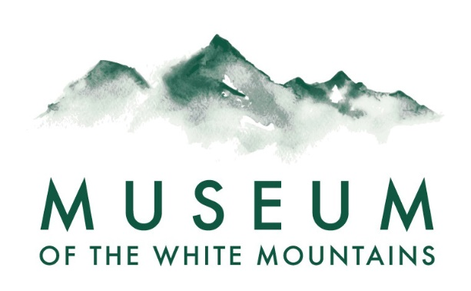
Lesson Plans for Teachers

Peace Tile Project

Objectives:
- To explore the symbolism of Peace
- To create a visual representation that communicates peace
- To participate in a legacy community project
- To bring previous study/explorations to a hands-on visual project
- To employ simple art concepts in creating an impactful design
- To apply reflection writing skills to summarize/communicate the exploration
Overview:
Begin by discussing the concept of peace. Have the group consider the visual representations of peace. Ask students to focus on one idea of peace that is meaningful to them. Have students choose from several color choices to create their personal peace tile. Conclude the activity by having students share their concept and artwork, in person and in a written summary.
Outcomes:
- Group mural
- Small group discussions/sharing
- Individual reflection writing
Materials:
- Unbaked clay tiles, paper, cardboard or whatever you have on hand
- Acrylic paint, light and dark colors
- Paint brushes
- An array of stencils if you have them: patterns, symbols, words
Peace concept discussion:
- Discuss different types of Peace:

  - Inner peace of mind
  - Peaceful body
  - Peace in the family
  - Peace in school/ in community
  - Peace in your state/nation
  - World peace
  - Peace between humans and other species

- Discuss symbols that represent peace: Introduce images as communicators, as signs/symbols- peace sign, hand signal, dove with or without olive branch
- Discuss what expressing peace in a painted tile would look like:
  - An image of a place: What is your “peaceful place”? Picture your peaceful place- what makes it peaceful for you? What are the sounds, views, textures? Examples: Sitting on a beach, hiking to the top of a mountain, walking in a forest, relaxing in your room, etc.
  - An image using an existing or your own symbol of peace: What symbol works for you? What colors do you imagine?
  - An image that illustrates peace between people: What are the parts of that story you could illustrate? Examples: hands holding hands, flags, people looking at each other, etc.
  - An abstract image: What colors, shapes, and lines do you imagine that would create that feeling of peace?
  - Adding words: Are there words or phrases that you want to add into your image?
- Tile painting process:
  - Background color, contrast with second color
  - Peace symbol and other pattern stencils and/or paint brushes
  - Words, or not
- Reflection writing/sharing: When your Peace Tile is complete, share what you were thinking and what you hope your tile communicates.
  - Partner sharing of tiles
  - Writing the story of your tile

